MSDS-6372 - Project 1
Akbar Thobani
Michael Weatherford
Tai Chowdhury

Goal 1: Prediction of Individual Property Values

Introduction

Home purchasing can be one of the largest purchases of an individual’s life. The price you pay for your home will affect your finances, budget, lifestyle and future. The sizeable loans, and long-term lengths involved with mortgages, also makes it a high-risk lending scenario for the bank. Being able to accurately predict a properties value based on the parameters of the home can be extremely beneficial to both the homeowner and lender.
With this study we have two main goals; first, we would like to predict the value of the property based off descriptive variables of the property second, we would like to forecast the mean property price for Jul 2015- July 2016. We are analyzing these goals for properties in Russia and were supplied data from a Russian financial institution named Sberbank.

Data Description

Test Test

Data Cleaning/Wrangling

Initial exploration of the data sets shows that we are missing approximately 5.6% of the data for both model data and project data sets (Figure 2). We did not want to remove the data rows and lose possibly important data in that row, so we imputed the missing data using Multivariate Imputation via Chained Equations (MICE). The problem using MICE for this data set is that there are many unbalanced factor variables. If you were to dummy code these variables there is a high chance that one column a linear combination of another. To correct for this, we changed the imputation method, so it was not a stochastic method. So, we utilized classification and regression trees to complete the imputation of missing data.
Figure 2 “Missing Variable Plot”
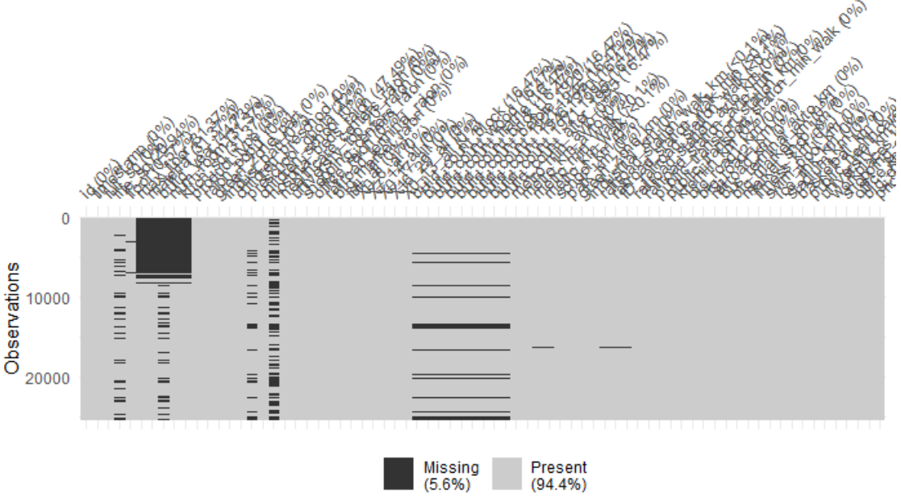

Figure 3 “Missing Variable Plot After Imputation”
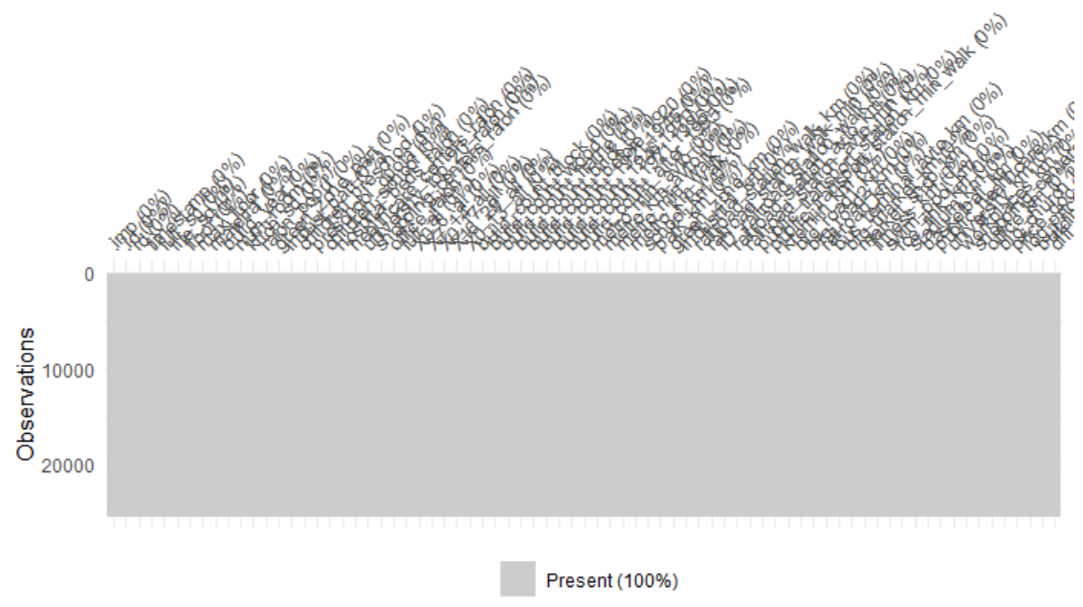

EDA

- Outlier identification was conducted on all continuous, numerical values. We used the Inter-Quartile-Range (IQR) method. Each column was evaluated and both the top and bottom 25% values were extracted, and any values beyond 1.5*IQR was considered an outlier and was replaced with either 5% or 95%th observation value.
- Please see “Data Cleaning/Wrangling” section for a description for missing value identification.
- We checked for collinearity using a correlation plot, which plots all variables against each other. The closer a value is to 1 or -1 the higher probability that those variables are collinearly related.
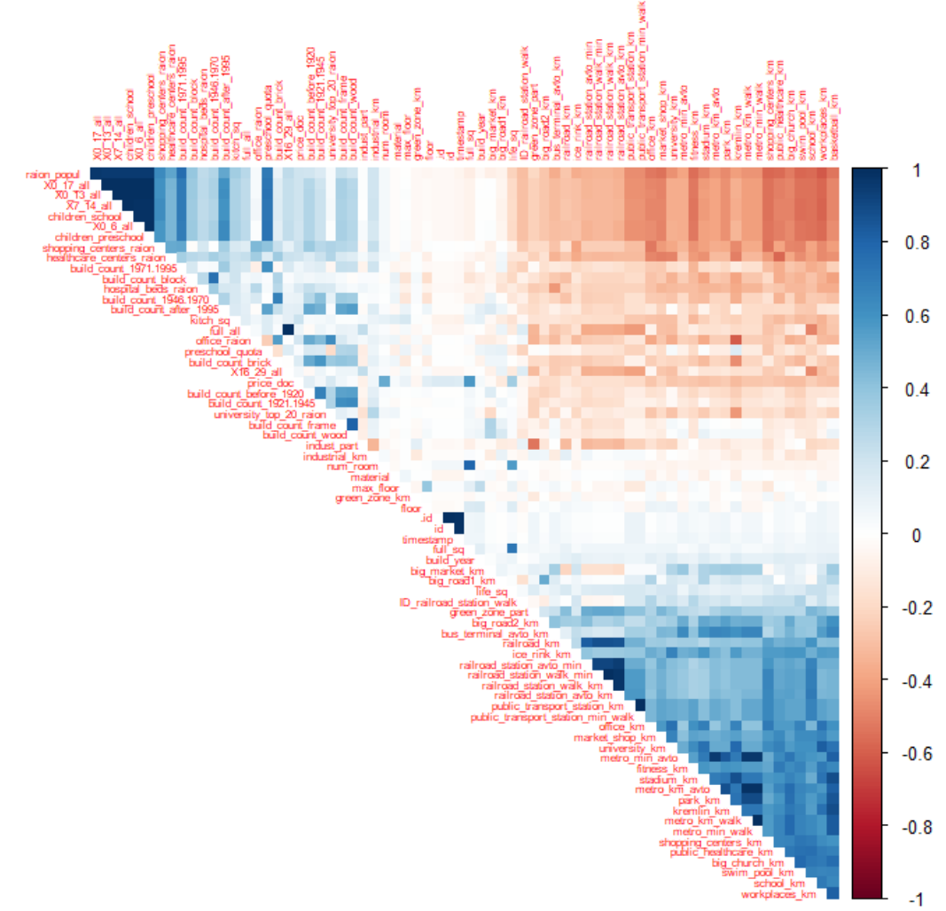
- Checking assumptions
- Variable Selection
- Anything else

Modeling Data for Prediction
We built three distinct models for our analysis:
- OLS with Forward selection and parameter estimates
- LASSO Using Cross Validation with estimates and selection
- OLS with Backward selection and parameter estimates

Method #1
OLS with Forward selection and parameter estimated

Method #2:
Lasso Using Cross Validation with Estimates and Selection details:

Method # 3:
OLS with Backward selection and parameter estimates

Model Comparison:

Prediction
All three above model appears to be performing equally well. However, looking at adjusted R-Square and AIC/AICC scores, OLS model with Backward and Forward selection method appears to be performing slight better.

Predictions and output file are submitted with the project submission.

Conclusion

Goal 2: Prediction of Mean Property Value by Year

Introduction

Data Cleaning/Wrangling
After cleaning transforming the TimeStamp data in Excel, we aggregate the dataset by Month, MonthYear and Average price in R:

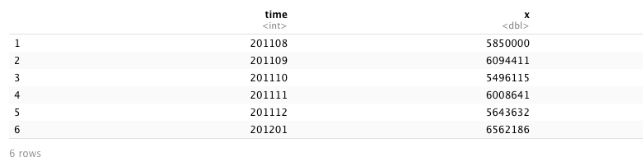

Plot Time Series
We plot Data AveragePrice Vs Time (MonthNumber). Data appears to be linearly corelated.
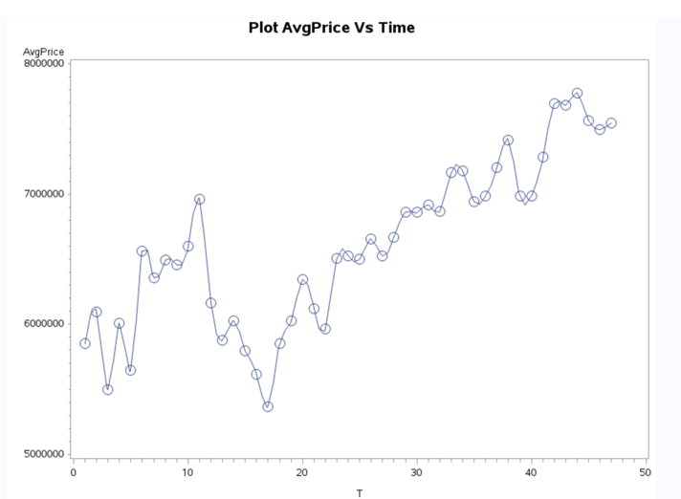

Model the Residual Series

We built a simple linear model between AvgPrice as response variable and MonthNumber. Fit Diagnostics below appears to show positive relationship between time and AvgPrice.
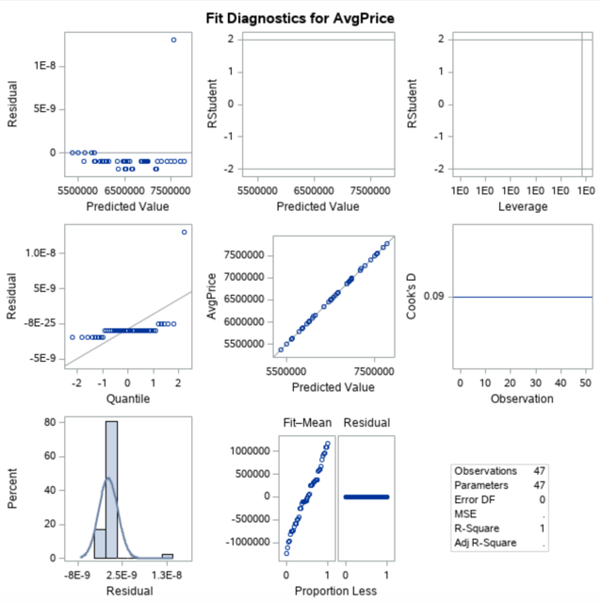

Forecast

Using Proc AutoReg we fit the time data and obtain Durbin-Watson statistics. Durbin Watson statistics score of 0.735 suggest there is positive autocorrelation exist in this timeseries data.
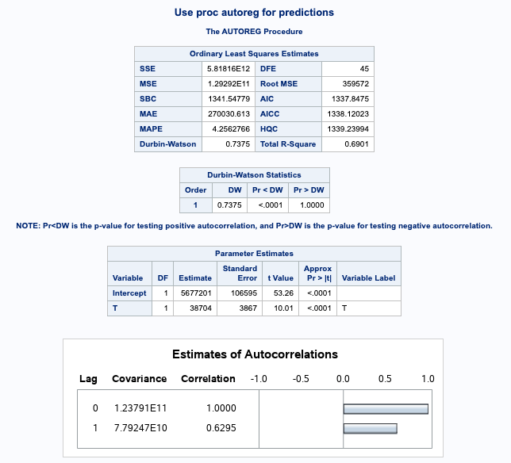

Further a ACF Vs Lag also confirms the autocorrelationship between the data:

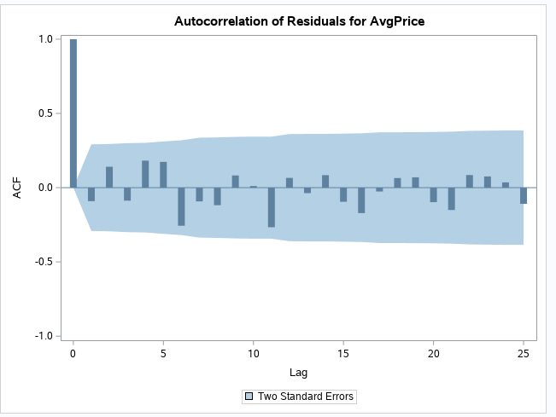

Forecast July 2015 to June 2016
Using our model, we generated the forecast for next 12 month with 95% confidence intervals. Full dataset CSV submitted with the project file.

t | predAutoReg | lower | upper | trend
48 | 7566384.957 | 6974835.104 | 8157934.81 | 7533113.015
49 | 7592422.344 | 6868208.86 | 8316635.828 | 7571478.036
50 | 7623027.26 | 6835908.851 | 8410145.668 | 7609843.056
51 | 7656507.383 | 6833868.093 | 8479146.672 | 7648208.076
52 | 7691797.416 | 6846311.8 | 8537283.031 | 7686573.097
53 | 7728226.766 | 6866330.601 | 8590122.932 | 7724938.117
54 | 7765373.305 | 6890537.732 | 8640208.878 | 7763303.138
55 | 7802971.305 | 6917136.166 | 8688806.444 | 7801668.158
56 | 7840853.495 | 6945115.176 | 8736591.813 | 7840033.179
57 | 7878914.579 | 6973882.271 | 8783946.887 | 7878398.199
58 | 7917088.274 | 7003080.428 | 8831096.121 | 7916763.219
59 | 7955332.858 | 7032490.902 | 8878174.814 | 7955128.24

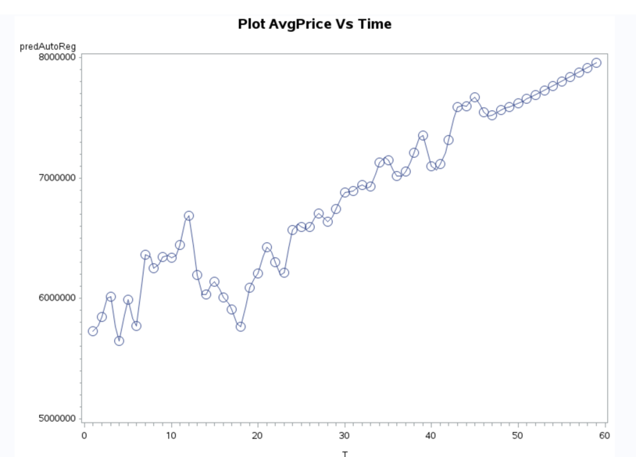

Conclusion Goal # 2:

